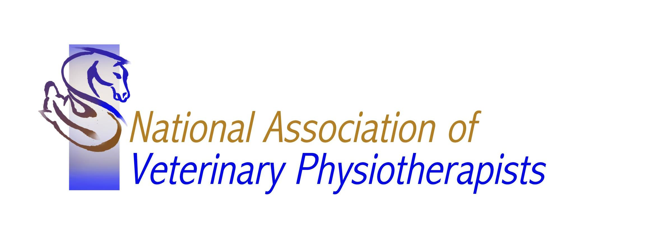

The National Association of Veterinary Physiotherapists
Annual General Meeting 22nd March 2017.

Attendance Form

Please complete and return this form either by email to navpsec@yahoo.co.uk or by post to NAVP Secretary. Highfields, Mill Lane. Cubbington. Warwickshire. CV32 7UD.

To enable us to finalise preparations please could you forward your attendance form by the latest 1st March even if you are unable to attend.

Name …………………..............................

I will/will not be attending the AGM on March 22nd.
*delete as appropriate

Special Dietary requirements…...........................................................

